A Charity Car Show at Lower Castle Park, Colchester on Sunday 5th September 2021.
A classic vehicle show and family fun day being held at lower castle park in Colchester. There will be arena events, children’s fun rides, craft & food stalls and a classic car display. Vintage, classic, British and thoroughbred cars, motorcycles and car clubs welcome.
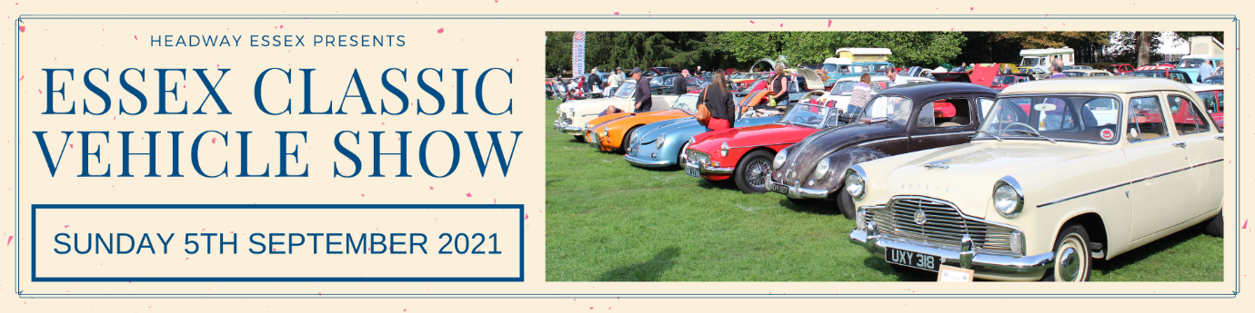
Rules of the Event
1. The event is open to Vintage, Classic and American vehicles registered before 1980 & Thoroughbred cars registered after 1980, also Motorcycles and small Classic commercial vehicles. No Modern substitute allowed if entered vehicle fails to proceed. Entry is at the discretion of the organisers. 2. The entrant must be the legal owner of the vehicle or be authorised by the owner to be using the vehicle. 3. Entries should only be on this form or via the Headway Essex website (www.headwayessex.org.uk). Photocopies of this form are acceptable. No change of vehicle can be made without prior notification and acceptance of the organisers. 4. All vehicles must be licensed and have a valid MOT certificate where required at the time of the event. 5. The use of the vehicle entered must be covered by appropriate insurance as required by law and entry warrants by signing this form that any person in charge of the vehicle on the event is so covered. 6. Entry may be refused if satisfactory evidence of valid insurance cannot be produced upon request.
Registration Form
Booking fee: Car £5 and Motorbike £3 All proceeds from this event go to Headway Essex
PLEASE USE BLOCK CAPITALS TO FILL IN THE FORM
Name

Email

Contact number

Address

Vehicle make and model | Vehicle year | Vehicle registration

I have read and accept the rules of this event. Signature here: . . . . . . . . . . . . . . . . . . . . . . . .
Would you like to stay connected with Headway Essex and receive marketing communications? Please tick: Yes ☐ No ☐
Closing date for entries is Friday 20th August 2021. Please note that vehicle entries are limited to 200 and will be allocated on a first come first serve basis.
Please send the completed form with the correct entry fee (Cheques made payable to Headway Essex) to 6th Floor Annex, Wellington House 90-92 Butt Road, Colchester, Essex, CO3 3DA
If you wish to pay via bank transfer, please send the correct entry fee to bank: CAF Bank, account name: Headway Essex, sort code: 40 52 40, account number: 00011576 with the words ‘Vehicle Show’ followed by your club name in the reference.
For queries, please contact Headway Essex on 01206 845945 or email fundraising@headwayessex.org.uk
For a full copy of Headway Essex’s privacy statement, visit www.headwayessex.org.uk.
Headway Essex Registered Charity Number: 1008807

